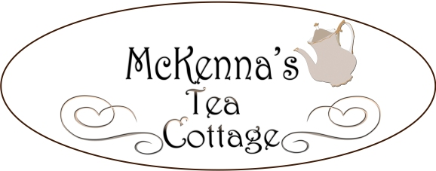

Queen Mum’s Tea ~ $27.00
Traditional pot of tea
Homemade scone with clotted cream and jam
Soup of the day or garden Salad
five tea sandwiches (assorted)
3 piece petite dessert
(add $4.00 for soup and salad)
Lady Hamilton Tea ~ $20.50
Traditional pot of tea
Homemade scone with clotted cream and jam
five tea sandwiches (assorted)
Prince & Princess Tea ~ $16.00
(for Children 10 years of age and under)
Pot of lemonade or tea
Scone with whipped cream and jam
Choice of peanut butter and jelly, turkey, ham, or cheese sandwich
Cookie

Little Duchess Tea ~ $11.50
Traditional pot of tea
Two homemade scones
with clotted cream and jam
Lady Price Tea ~ $15.00
Traditional pot of tea
Half sandwich & Soup or Garden Salad
Quiches of the Realm ~ $14.50
Served with a side salad or cup of soup
Lorraine: Swiss cheese, scallions and bacon
Chicken: Cheddar cheese and broccoli
Vegetarian : Swiss cheese, spinach, mushrooms and onions

Salads
Served with a baguette and butter or scone
Add a scoop of tuna or chicken salad for $3.50
Earl of Yorkshire Spinach Salad ~ $10.50
Fresh spinach leaves, mandarin orange slices, almond slivers, bacon bits, and raspberry vinaigrette
The Red Coats Pasta Salad ~ $10.50
Bow tie pasta, broccoli, black olives, artichoke hearts, and tomatoes with Italian dressing
The King’s Delight ~ $11.50
Mixed greens, cucumbers, purple onions, tomatoes and shredded carrots
McKenna’s Salad Sampler ~ $13.50
An array of our three salads
Sandwiches ~ $14.00
Served on a baguette with choice of garden salad or cup of soup
Albacore Tuna: Scallions, celery, sun-dried tomatoes with lemon pepper mayonnaise
Egg Salad: – Spinach, egg, mustard, and mayonnaise
Chicken Salad: Celery, chopped walnuts, golden raisins and diced purple onions
Roast Beef: Swiss cheese, romaine, tomato and mayonnaise
Turkey: Provolone, romaine, tomato and mayonnaise
Smoked Ham: American cheese, romaine, tomato and mayonnaise
Vegetarian: Cheese, cucumber, purple onion, tomato, spinach and honey mustard dressing
Peanut Butter & Jelly ~ $7.00
Desserts
3 Piece Dessert ~ $4.50 (options vary)

Sides
Scone ~ $3.50
(includes jam & cream)
Garden Salad ~ $4.50
Baguette ~ $2.00
Cup of Soup ~ $4.00
Bowl of Soup ~ $7.00
Beverages
Pot of Tea (hot or iced) ~ $5.00
Tea Refill - $2.50
Pink Lemonade ~ $2.75
Coffee ~ 2.50
Hot Chocolate ~ $1.75
Milk ~ $1.75

Loose leaf tea to take home (makes 4-5 pots)
$10.00 (With glass jar)
$8.00 (Without Jar)

An 18% gratuity will be added to all tea services of 4 or more
($3.00 will be added to all gluten & vegan selections / 48 hour notice needed)
Reserve Tea Room or Garden Patio for Special Occasions, Birthdays, Tea Parties, Bridal Teas, Baby Showers, Graduations, Retirement Parties
Accepting Visa, MasterCard, Discover, Cash - sorry, no checks.
Prices are subject to change without notice

