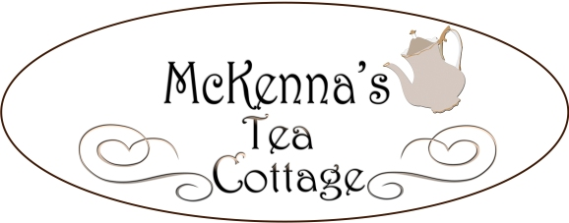

Queen Mum’s Tea ~ $27.00
Traditional pot of tea
Homemade scone with Devonshire cream and jam
Soup of the day or garden Salad
Assorted sandwiches
Dessert
Lady Hamilton Tea ~ $20.50
Traditional pot of tea
Homemade scone with Devonshire cream and jam
Assorted sandwiches
Prince & Princess Tea ~ $16.00
(for Prince & Princess’s 10 years of age and under)
Pot of lemonade or decaffeinated tea
Miniature scone with whipped cream and jam
Choice of peanut butter and jelly, turkey, or cheese sandwich
Petite dessert
Little Duchess Tea ~ $11.50
Traditional pot of tea
Two homemade scones
with Devonshire cream and jam
Lady Price Tea ~ $10.50
Traditional pot of tea
Two crumpets with choice of butter and jam
or cheddar cheese and scallions

Quiches of the Realm ~ $14.50
Served with a side salad or cup of soup
Lorraine: Swiss cheese, scallions and bacon
Chicken: Cheddar cheese and broccoli
Vegetarian : Swiss cheese, spinach, mushrooms and onions

Sandwiches ~ $14.00
Served on a baguette with choice of garden salad or cup of soup
Albacore Tuna: Scallions, celery, sun-dried tomatoes with lemon pepper mayonnaise
Chicken Salad: Celery, chopped walnuts, golden raisins and diced purple onions
Roast Beef: Swiss cheese, romaine, tomato and mayonnaise
Turkey: Provolone, romaine, tomato and mayonnaise
Smoked Ham: American cheese, romaine, tomato and mayonnaise
Vegetarian: Cheese, cucumber, purple onion, tomato, spinach and honey mustard dressing
Peanut Butter & Jelly ~ $7.00

Salads
Served with a baguette and butter
Add a scoop of tuna or chicken salad for $3.50
Earl of Yorkshire Spinach Salad ~ $10.50
Fresh spinach leaves, mandarin orange slices, almond slivers, bacon bits, and raspberry vinaigrette
The Red Coats Pasta Salad ~ $10.50
Bow tie pasta, broccoli, black olives, artichoke hearts, and tomatoes with Italian dressing
The King’s Delight ~ $11.50
Mixed greens, cucumbers, purple onions, tomatoes and shredded carrots
McKenna’s Salad Sampler ~ $13.50
An array of our three salads
Dessert ~ $4.50
A delicious choice from our silver tray
Sides
Scone ~ $3.50
Garden Salad ~ $4.50
Baguette ~ $2.00
Cup of Soup ~ $4.00
Bowl of Soup ~ $7.00
Extras
Devonshire Cream
Jam
Salad Dressing
Loose leaf tea to take home
$10.00 includes jar
$8.00 Refill
Beverages
Pot of Tea ~ $5.00
Premium Pot of Tea ~ $8.00
Iced Tea ~ $2.75
Lemonade ~ $2.75
Coffee ~ 2.50
Soda ~ $2.50
Hot Chocolate ~ $1.75
Milk ~ $1.75
Prices are per person.
*If you wish to share a plate, please add $4.00*

Reserve Tea Room or Garden Patio for Special Occasions, Birthdays, Tea Parties, Bridal Teas, Baby Showers, Graduations, Retirement Parties
Weekend reservations highly recommended.
An 18% gratuity will be added to all parties of 2 or more
Accepting Visa, MasterCard, Discover, and Cash - sorry, no checks.
Prices are subject to change without notice

